Problem 2: Bron-Kerbosch Execution
Given the undirected graph G with vertices V={A,B,C,D} and edges E={AB,AC,BC,CD}.
The adjacency list representing the neighbors N(v) for each vertex is:

N(A)={B,C}

N(B)={A,C}

N(C)={A,B,D}

N(D)={C}

1. Initial call to the algorithm
In the beginning, the result clique R and the excluded set X are empty, while the candidate set P contains all vertices.

R=∅

P={A,B,C,D}

X=∅

2. Trace the first two recursive calls
Assuming we select vertices from P in alphabetical order to find the first clique:

Step 1 (First recursive call with v=A):
We move A into R, and restrict P and X to the neighbors of A.

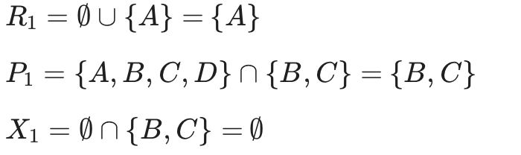
Call triggered: BronKerbosch({A}, {B, C}, ∅)

Step 2 (Second recursive call with v=B from P1):
We move B into R1 , and restrict P1and X1to the neighbors of B.

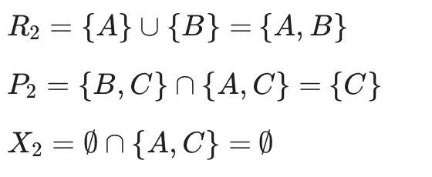
Call triggered: BronKerbosch({A, B}, {C}, ∅)
(Note: One more recursion picking C would yield R={A,B,C}, triggering the base case to report a clique.)

3. List all maximal cliques. Which one(s) are maximum?

Maximal Cliques: A maximal clique is one that cannot be enlarged by adding any more adjacent vertices. In this graph, there are two maximal cliques: {A,B,C} and {C,D}.

Maximum Clique: A maximum clique is the maximal clique with the largest number of vertices. The maximum clique here is {A,B,C} (size 3).

